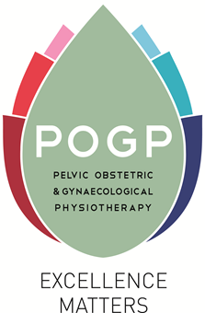

Application for funding from the Ruth Hawkes
Early Career award

Closing date: January 31st and July 31st each year

Please complete ALL the following sections

PERSONAL DETAILS
Full name as it appears on your registration form

- The award entitles the successful applicant to the three courses listed below

Please indicate your preferred choice of date and venue

Pregnancy Related Physiotherapy: the childbearing year – an entry level course
Preferred date and venue:…………………………………………………………….

Pelvic Health Physiotherapy: Female urinary dysfunction – an entry level course
Preferred date and venue:…………………………………………………………….

Pelvic Health Physiotherapy: lower bowel dysfunction – an entry level course
Preferred date and venue:…………………………………………………………….

- Please provide an anonymized supporting statement (500 words max.)

- Please show reasons why POGP should consider your application.
- How relevant is this to your career development and future CPD?

Click here to enter your text

Please return the following completed documents to awards@thepogp.co.uk

- POGP Registration form for Bursaries, awards and prizes
- Application form
- Curriculum Vitae (ANONYMISED)

Closing dates: January 31st or July 31st

